Course Upload Checklist - Standard Course Upload (required)
☐ | - Provide Course Description (In this course you will learn…)
☐ | - Provide Course Duration in minutes (Ex. 15 minutes)
☐ | - Provide 2 Images for course  - 1 for course image: 900 x 372 dpi/12.5 in x 5.167 in  - 1 for thumbnail image: 800x400 dpi/11.11 in x 5.5 in  - Format = jpeg
☐ | - Provide files for your course – PowerPoint, Word/PDF documents, SCORM file, Video, YouTube links.  - Indicate the order in which the files should be listed in the course.  - Indicate which files are required for the completion of the course.  - Video external links can be YouTube or Vimeo – These can be standalone or within a PowerPoint or SCORM file. Warning: Be aware this is an external link, and we can’t track its continued availability (ie if videos are deleted from their location.)  - A standalone video can be uploaded as a playable object. The maximum size of the file is 800 MB. The video files format can be 3GP, AAC, AVI, FLV, MP4, WMV, MPEG-2, MOV or MP3.  - PowerPoint should be PPT, or PPTX format. Each slide needs to have a title. If your PowerPoint is longer than 30 slides we suggest breaking into parts, Part 1, Part 2 etc.  - Word documents should be converted into pdf files to protect the integrity of the content, unless it is a document that will be edited by the student (ie templates.)
☐ | - Provide Test Questions with answers.  - Test questions can be single choice, multiple choice and True/False.  - Indicate if questions should be presented in the order you list them or if want the order to be randomized.  Recommendation for randomized test: for example, a 10-question test should have a bank of questions of 20. This will ensure that the test is truly randomized, and it has a different selection of questions if the student needs to take the store more than once.
☐ | - Course Certificate  - Default Course Certificate without logos (free)  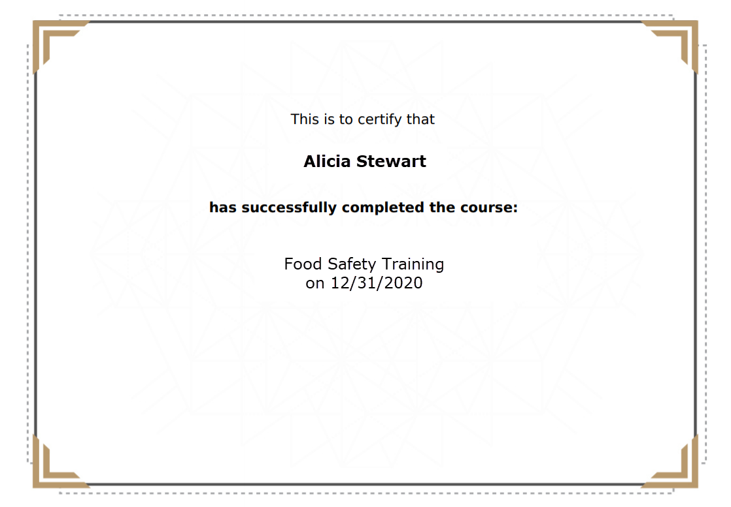  - Custom Course Certificate – we can create a custom certificate with your logo and signatures that you can use for all your custom courses. Cost = $400 one-time fee. Once created, you can reuse the certificate for other custom courses. 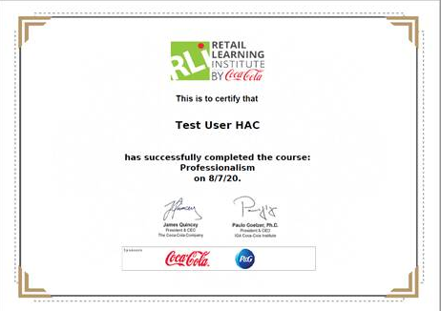
☐ | - Course Visibility  - Assignment by the Administrator – only the administrator can enroll students in the course.  - Custom Catalog – the course is added to your company custom course catalog. We can create a custom catalog visible only to your users, that allows them to view your courses and self-enroll. Cost = $400 one-time fee.  - Automated Enrollment – we can set the course to be automatically assigned, based on any criteria from the user profile. Cost = varies

Advance Course Upload features (optional)
☐ | - Navigation – free or enforced. This controls the order in which the users will go through the different elements that make up your course (ie, they will see the video first, then view the pdf and finally take the test)
☐ | - Unenrollment – will the student be able to self-unenroll from the course.
☐ | - Number of attempts – the student can have a specific number of opportunities to complete the course or can have unlimited number of attempts.
☐ | - Validity days or dates – the course can be set to be available to the student for a specific period of time. For example, a course can be valid for 30 days from the enrollment date or from Jan 5th until Feb. 1st. The student must complete the course within the allocated time frame.
☐ | - Downloadable materials - the course can have additional files/materials that the student can download. For example, manuals, forms, documents, videos, checklist, presentations, charts, etc. These can be reference materials not required to complete course.
☐ | - Course enrollment link - this is a link that you can provide to the student to go directly into the course after entering their login.
☐ | - Rating - the students can rate the course using a 5-star rating system.
- Equivalencies - a student who has taken course A, will not need to take course X, because they are equivalent. For example, a student takes the Sexual Harassment for California, then that course can be equivalent to the standard Sexual Harassment course.
- Course Acknowledgement of Completion - an option that can be added in the beginning or end of course where the learner must acknowledge they read terms of use or acknowledge they completed the review of the course. They scroll through the acknowledge text, and at the end click an area that states, “I understand these terms.”
- Custom Course Cost - Custom courses start at $500. This includes 4 hours of course development and 2 rounds of revisions.

Revisions
The initial cost includes 2 rounds of revisions.
- Revision #1 - The client must provide all changes in a single document. A meeting will be scheduled to clarify any questions about the requested changes/additions. The first revision will be the first draft of the course with the changes and added materials requested by the client.
- Revisions #2 - The client will receive a course draft with all the changes requested. The client evaluates the draft and provides feedback (structure of course, new images, audio changes or additions, etc.)
- Final Version - Once all comments, ideas and questions are consolidated the final version of the course will be delivered. Only corrections like typos or error will be done to the final version.
Note: Additional revisions or changes thereafter will have an extra cost.

Course Upload Options
Slides Converter
A PowerPoint file can be automatically converted to a viewable course file with navigation controls like previous/next buttons and a table of content. The ppt is converted as is. Make sure the ppt does not have animations.
Storyline File (SCORM)
A PowerPoint can be imported into Storyline (the software we use to create the courses.) In Storyline the course can be modified in all possible ways. The process is more laborious and may have added costs depending on the length of the course and the customizations requested.
The course can have standard navigation and completion upon viewing the course. Or it can have our course navigation template making the course look like one of our courses, which is more labor intensive.

