Corporate University (CU) Setup Checklist

This document explains the setup options available to customize your corporate university. Each option is described and if necessary, illustrated with an image to clarify the option. These are options and not all are required to setup your corporate university.

☐ | - CU Name - this is your E-Learning platform name, and will appear on the browser's tabs and top bar of the page  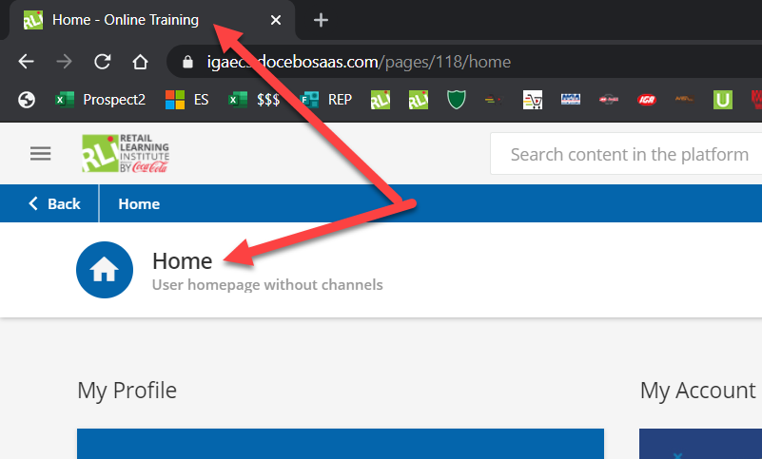
☐ | - Homepage tag line - this is message or description that appears below the CU name. It is not required.  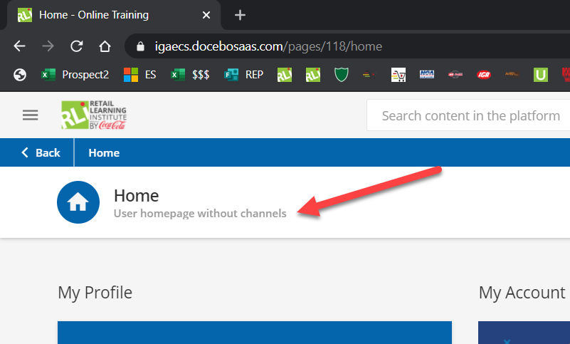
☐ | - CU branding logo – your logo will appear on the top left corner of your Online Training webpage.  - Dimensions: Max. image size is 380x72 px  - Format: JPG, PNG, JPEG and GIF  - Maximum file size: 2MB  Tip: it is best if you have a logo with a transparent background  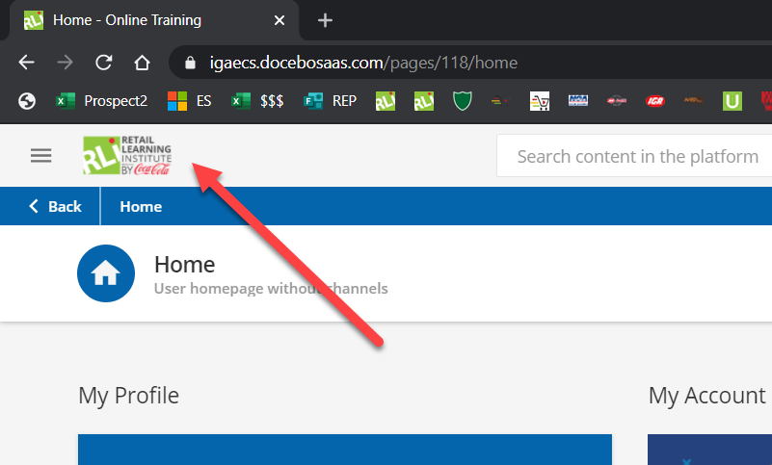
☐ | - CU browser favicon – your website's favicon is the small icon that appears on the browser window tab.  - Dimensions: 16x16 px  - Format: PNG image  Tip: this is a very small image, the simpler the image is the better it will look. Think a simplified version of your logo or maybe an icon that identify your logo.  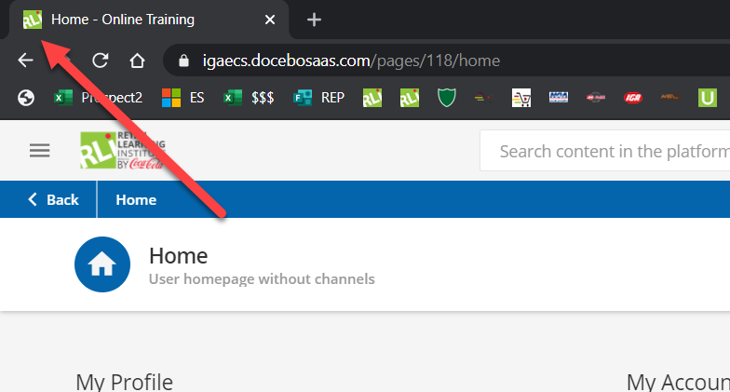
☐ | - Sign up page background image - when designing the image keep in mind the sign in box is centered and it is semi-transparent. If you have a busy background, it will make the Sign In box less readable. The sign in box will be shown on top of your background image, any text or graphic in that area will not be clearly visible.  - Dimensions: 1280x720 px.  - Maximum file size: 10MB  Tip: try to keep your images towards the edges, leaving a clean area around the Sign In box, to ensure that if the users increase the size of the screen the images will not interfere with the area where the enter their login.  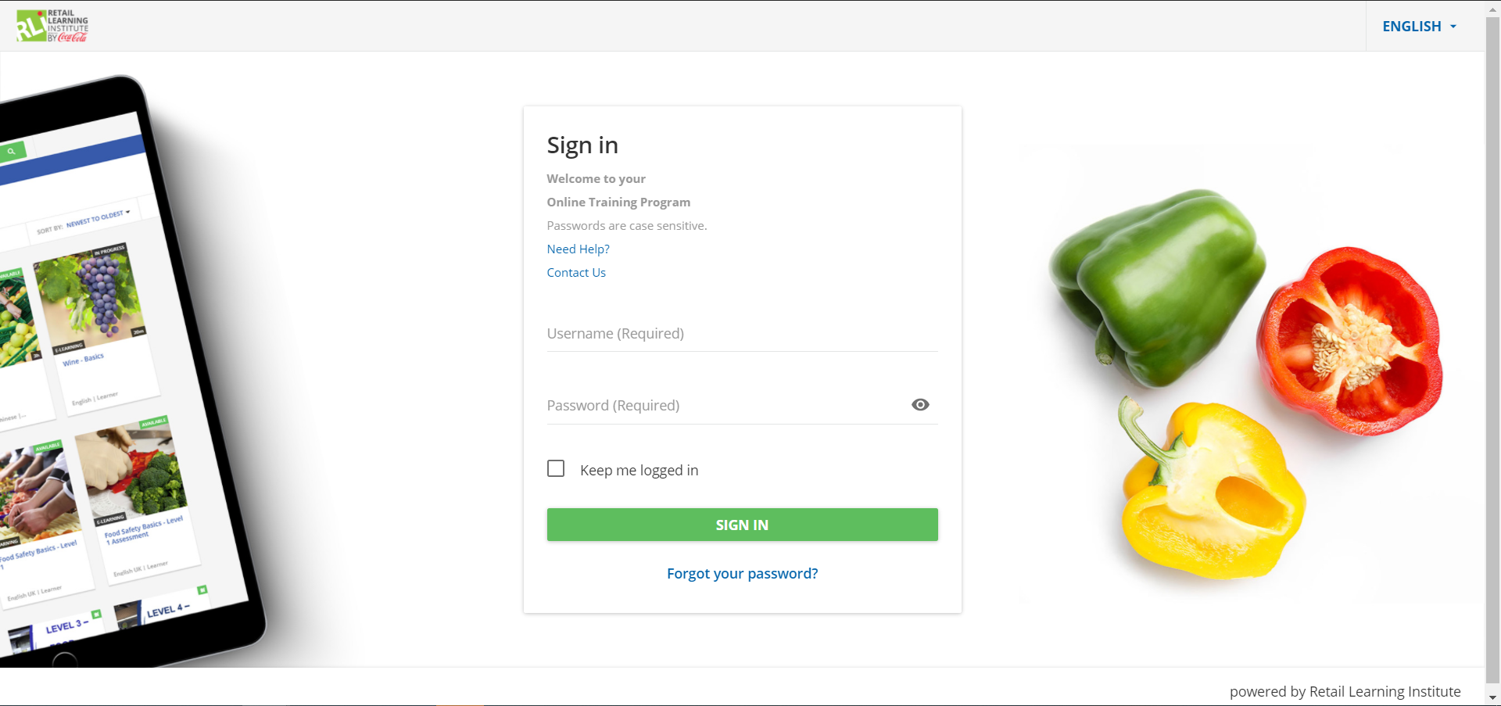
☐ | - CU URL – the domain that you would like us to use for your CU login page. Choose one of the options below.  - Standard - https://igaecs.docebosaas.com/cuname [name of your corporate university ie jmh, jmh-cu, companytraining]  - Custom URL – we can use any URL that you have in your domain or that you have purchased. For this, the company from which you purchase the URL must provide you with a Certificate (a code) that we need to connect the sign-up page to the URL.
☐ | - Virtual Coach  - Enabled – the virtual coach will remind users which courses they have in progress and will make course recommendations based on what other users also took.  - Disabled – no virtual coach function.
☐ | - Use user’s email address as username: yes or no?
☐ | - User will receive the standard email with their login when a user is created: yes or no?
☐ | - Color/Theme options: the standard template uses a blue color scheme. It can be changed to any color scheme that matches your company colors. We can discuss further.
☐ | - Interface page – both the user and the administrator pages can be modified and its layout adjusted. These pages work as a table grid, with a max of 20 widgets (cells). The table can be build with rows of the following format.  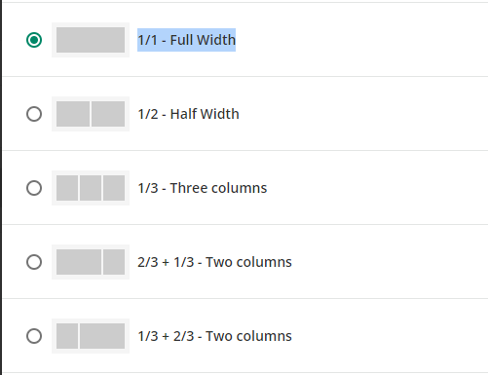  - 1/1 Full Page Width: ie Top banner - 1390x(height can be adjusted)  - 1/2 Half Width (both images equal width): ie mobile app images - 690x(height can be adjusted)  - 1/3 Three Columns (three columns equal size): ie the profile, my training, news row - each image 444x(height can be adjusted)  - 2/3 + 1/3 Two columns with one image that is a third and the other two thirds. The one that is a third is 444x(height can be adjusted), the one that is two thirds 914x(height can be adjusted),  Note:  Images in the same row should have the same height.

